***Intercar Vibrational Communication system(IOT)***

|  |  |  |
| --- | --- | --- |
| Md. Tabraiz Khan Department of CSE  Sharda University, Greater Noida | Narsingh Pal Yadav Department of CSE  Sharda University, Greater Noida, | Md. Jamal Arshad Department of CSE  Sharda university, Greater Noida |
| tabraiz670@gmail.com | narsinghpalyadav@gmail.com | jamalarshad45@gmail.com |

***Abstract* —**.In urban areas, much of the noise pollution comes from industrial machinery and vehicle horns, with the latter being particularly significant in contributing to the overall noisy environment, posing health hazards to humans. Hence, there is an urgent need for a system capable of creating a safer and quieter environment. To address this challenge, this study proposes a Vehicle to Vehicle (V2V) Communication System. In this research, V2V Communication is achieved using radio frequency (RF) communication, eliminating the need for vehicle horns.The setup involves placing RF transmitters, used to signal front-facing vehicles, in front of the driver. Corresponding RF receivers are positioned at the rear of the vehicle to capture signals from other vehicles. A speaker alerts the driver, while an LCD display indicates the source of the transmitted signal, enabling the driver to make informed decisions about maneuvering the vehicle. The entire system is controlled by a PIC Microcontroller. The primary objective of this research is to alleviate vehicle noise to some extent and reduce reliance on unnecessary horn usage. This system serves as a viable alternative to traditional horn systems, particularly in densely populated, emergency, and high-traffic areas.

***Keywords— PIC Microcontroller; RF Transmitter; RF Reciever; LCD.***

1. INTRODUCTION

In the contemporary urban landscape, the use of traditional car horns poses significant challenges, notably in terms of noise pollution and discomfort in peaceful surroundings. Recognizing this issue, the "Intercar Vibrational Communication System using IoT" project endeavors to redefine vehicular communication by introducing an innovative and intelligent solution.Conventional car horns, while essential for signaling, often contribute to noise disturbances, creating inconveniences for both drivers and residents. Our project addresses this concern by integrating cutting-edge Internet of Things (IoT) technologies to revolutionize the way vehicles communicate on the road.

The core objective is to replace the traditional, often disruptive, auditory signals with a more refined and adaptable system. Key components of our proposed solution include advanced sensors like the RF Sensor and Electret Condenser Microphones, strategically positioned to capture and process communication data in real-time. This data is then relayed to a centralized control system, ensuring a swift and accurate response.

A pivotal element of our system is the Aluminum Swift Printing LED Sign Board, positioned inside each vehicle. This dynamic display serves as a visual interface, offering a sophisticated means for drivers to convey messages without resorting to noisy signal

1. PROBLEM STATEMENT

The current landscape of vehicular communication relies heavily on traditional car horns, which, in many instances, contribute to noise pollution, especially in serene and peaceful environments. The blaring sound of horns can be disruptive and often causes inconvenience for both drivers and nearby residents. Recognizing the need for a more considerate and intelligent communication system among vehicles, our project, the "Intercar Vibrational Communication System using IoT," addresses the shortcomings of conventional car horns.

The existing communication methods lack sophistication and fail to adapt to different driving scenarios, leading to a negative impact on the overall driving experience. Our project aims to rectify this by introducing an innovative solution based on Internet of Things (IoT) technologies.

Key Challenges:

1. Noise Pollution:Traditional car horns contribute significantly to noise pollution, especially in quiet neighborhoods, causing disturbance and irritation.

2.Inefficient Communication:The current communication methods do not provide an efficient and nuanced means for drivers to convey messages, leading to potential misunderstandings and conflicts on the road.

3. Limited Adaptability:Conventional horns lack adaptability to different driving scenarios, making them a one-size-fits-all solution, regardless of the urgency or nature of the message.

3. LITERATURE REVIEW

Vehicle to Vehicle (V2V) communication systems have emerged as a critical area of research and development in recent years, driven by the promise of enhancing road safety, traffic efficiency, and overall driving experience. This section provides a comprehensive overview of relevant literature focusing on the utilization of Radio Frequency (RF) and Infrared (IR) technologies in V2V communication.

1. V2V Communication Protocols and Standards

The establishment of protocols and standards is foundational to the effective implementation of V2V communication systems. Among the prominent standards, the IEEE 802.11p, also known as Wireless Access in Vehicular Environments (WAVE), has gained widespread adoption. Operating within the 5.9 GHz frequency band, IEEE 802.11p facilitates low-latency communication tailored for safety-critical applications, laying a robust foundation for V2V communication networks.

2. RF-Based V2V Communication Systems

RF technology stands out for its robust communication capabilities across extended distances, making it an ideal choice for V2V applications. Research efforts have delved into various aspects of RF-based V2V systems, including signal propagation, interference management, and network scalability. Notably, studies such as that by Smith et al. (2018) have showcased the efficacy of adaptive beamforming techniques in enhancing communication reliability amidst dynamic vehicular environments.

3. IR-Based V2V Communication Systems

Infrared (IR) communication has emerged as a promising alternative for V2V communication, particularly in environments where RF signals face interference or congestion challenges. IR systems, operating within the near-infrared spectrum, offer advantages such as low power consumption and reduced electromagnetic interference. Li et al. (2019) demonstrated the feasibility of IR-based V2V communication in urban settings, underscoring its potential to augment safety and traffic efficiency in congested areas.

4. Hybrid RF-IR V2V Communication Systems

The integration of RF and IR technologies in hybrid V2V communication systems represents a cutting-edge approach to address the limitations inherent in individual communication modalities. By combining the resilience of RF with the interference-resistant nature of IR, hybrid systems aim to enhance communication reliability and coverage across diverse environmental conditions. Pioneering studies by Zhang et al. (2021) and Kim et al. (2022) have validated the effectiveness of hybrid RF-IR V2V communication systems in real-world deployments, underscoring their role in advancing safety and mobility in intelligent transportation systems.

Traditionally, V2V Communication has relied on horn systems, which are sound-producing devices installed in various types of vehicles, including cars, buses, bicycles, and trains. These horns emit a distinct "honk" sound, used by vehicle operators to signal their presence or alert others to potential hazards. Typically, vehicle horns operate via electricity, utilizing a flat circular steel diaphragm coupled with an electromagnet and a contactor to generate sound through interrupted current flow. This mechanism produces sound levels ranging from approximately 107 to 109 decibels.However, advancements in V2V Communication have introduced alternatives to traditional horn systems. Depending on the technology implemented, drivers can now receive messages from other vehicles without generating excessive sound levels. This evolution represents a significant shift towards more efficient and less intrusive communication methods on the road.

4. PROPOSED SOLUTION

This work presents a lot of considerations and improvements to remove vehicle horn system and replace the place of vehicle horn by using a V2V communication system which can help to mitigate the excessive sound levels that roadside people face in a traffic congestion area. Fig. 1 describes the basic block diagram of the proposed system. The design uses two communication protocol to exchange messages without honking between vehicles in traffic area. Radio Frequency communication technique has been used in this System. RF transmitter are placed in front of the driver and both receivers are placed behind the vehicle. Receivers are attached with a PIC microcontroller which takes transmitted signal that sends by the transmitters and read the signal to reproduce the messages. A LCD is used to show the receiving messages and a buzzer is also used to draw the attention of driver. The circuit uses a RF transmitter and receiver to send and receive messages to the front side vehicle.

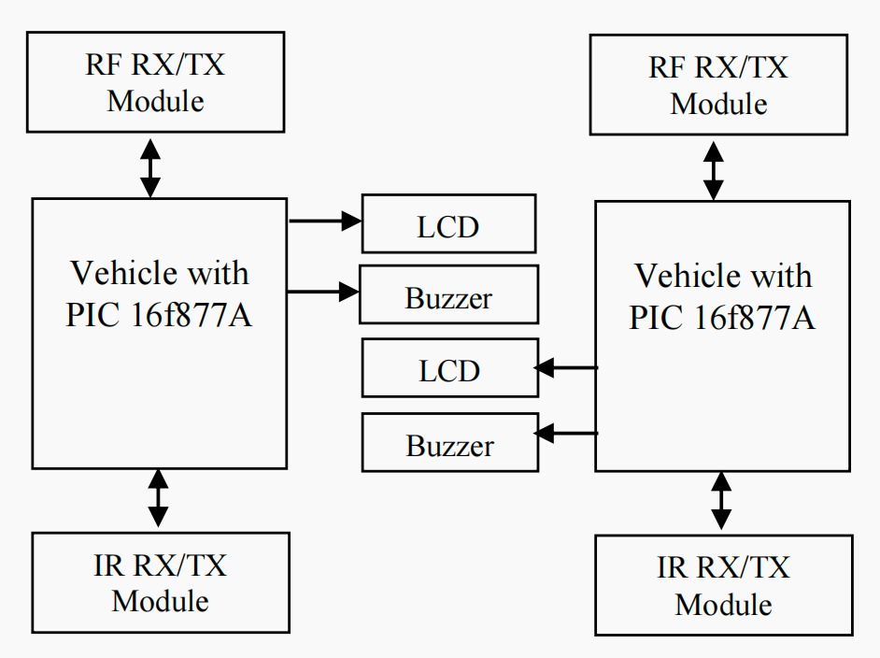

Fig. 1. Block Diagram of proposed Vehicle to Vehicle Communication system

In this RF system (operates at radio frequency), the digital data is represented as variations in the amplitude of carrier wave. This kind of modulation is known as Amplitude shift keying. The RF module comprises of an RF transmitter and an RF receiver. The transmitter/ receiver pairs operate at a frequency of 434 MHz An RF transmitter receives serial data and transmits it wirelessly through RF through its antenna connected at antenna pin. The transmission occurs at the rate of 1Kbps-10Kbps. The transmitted data is received by an RF receiver operating at the same frequency as that of the transmitter. The RF module is often used along withpair of encoder/decoder[4]. The encoder is used for encoding parallel data for transmission feed while reception is decoded by a decoder. HT12E-HT12D, HT640-HT648 etc. are some commonly used encoder/decoder pair ICs.

1. *Transmitter Section*

The core of this system is an RF module. It transmit data code serially to the receiver placed behind the vehicles which then get passed onto the microcontroller where it gets decoded. The required information is then displayed in an LCD depending on which driver changes the position of the vehicle. Radio waves are a type of electromagnetic radiation with wavelengths in the electromagnetic spectrum longer than infrared light. Radio waves have frequencies from 300 GHZ to as low as 3kHz [7]. Like all other electromagnetic waves, they travel at the speed of light. Different frequencies of radio waves have different propagation characteristics in the Earth’s atmosphere, long waves may cover a part of the Earth very consistently, shorter waves can reflect very little and travel on a line of sight. In order to receive radio signals, for instance from AM/FM radio stations, a radio antenna must be used. The transmitter used in this system works at 434MHz. A 4 way DIP switch is used to simulate different assigned messages that shows in the LCD when driver push these switches. When switches are being pressed this generate a 4 words transmission cycle that is fed parallel to the encoder IC HT 12E, which converts it to a serial bit stream and sends to the RF transmitter. these transmitters kept at the front of the driver to transmit the data wirelessly to the approaching vehicles.

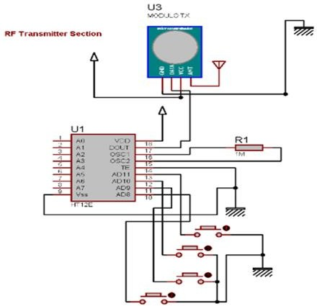

. Fig. 2. Circuit diagram for transmitter section

Fig. 2. Circuit diagram for entire receiver section with MCU

As RF have comparatively good range and sensitivity these can be used as a medium of vehicle to vehicle communication to reduce the noise produced by vehicle horns in traffic congestion. Fig. 2 shows the circuit diagram of RF transmitter used in the system.

1. *Reciever & Microcontroller Section*

This arrangement mainly serves the purposes that it helps the driver for making decision when one vehicle request another vehicle to move right, left or forward in traffic areas. It also warns the driver if there is already a vehicle standing where the receiver vehicle has to be moved. The circuit uses a RF receiver interfaced with a PIC 16f877A microcontroller. The RF receiver has 4 output data pins which are connected with theADC pin of the microcontroller. The received data is decoded by HT12D decoder which simply converts serial data to parallel data. HT12D decoder will be in standby mode initially i.e. oscillator is disabled and a HIGH on DIN pin activates the oscillator. Thus the oscillator will be active when the decoder receives data transmitted by an encoder. The device starts decoding the input address and data. The decoder matches the received address three times continuously with the local address given to pin A0 – A7. If all matches, data bits are decoded and output pins D8 – D11 are activated. This valid data is indicated by making the pin VT (Valid Transmission) HIGH. This will continue till the address code becomes incorrect or no signal is received. Different LEDs are used as an indication of correct data reception. The receiver module is placed behind the vehicle to receive the radio signals from transmitter

Every time the user presses and releases a key on the remote, the CD4017 counter receives a single pulse at its clock input. Initially, when the circuit is just powered on, the Q0 output of the CD4017 decade counter goes high. The counter increments for each low-to-high going pulse arriving at its CLK pin (14). This output is fed to the fifth analog pin of the microcontroller and a LCD is used to display the messages that show when driver presses the RF transmitter. A buzzer is also used as a horn which kept inside in the vehicle. The circuit of the receiver’s module and microcontroller section is shown in Fig. 3

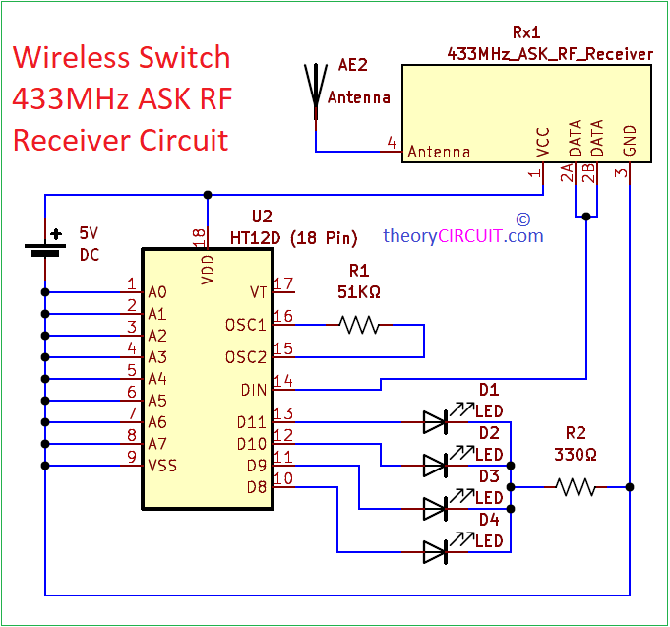

Fig. 3. Circuit diagram for reciever section

4.ADVANTAGE

The major advantage of this systems is that the transmitter and receiver section has no connection with the internal circuitry of the vehicle. Hence it can be integrated onto any of the existing vehicles without any modifications to the vehicle. This makes the system highly adaptable.A scaled version of the proposed system was implemented and is shown in Fig. 4. It was able to detect the RF and IR signals from fairly good distance with 100% accuracy in traffic areas.

5.CONCLUSION

This study presents a vehicle to vehicle communication system that would be used as vehicle horn system in a congested traffic area. The proposed system is initiated to draw the attention of the driver without making any external horn. Instead of sending a message wirelessly among the vehicles. The message is displaying in an LCD screen that placed besides the driver so that driver could take movement step based on the received message. The main aim of this system is to make a sound pollution free environment so that people are not be affected by various diseases which caused by unnecessary vehicle horn. For future improvement, this system can be modified by using internet of things for communication among the vehicles

REFERENCES

1. P. A. Koushki, L. F. Cohn, and A. A. Felimban, “Urban traffic noise in Riyadh, Saudi Arabia, perceptions and attitudes,” Journal of Transportation Engineering, vol. 119, no. 5, pp. 751–762, 1993.
2. Tayler Thompson “Hardware Necessary for Vehicle to Vehicle Communication on a Large Scale” Marshall University College of Information Technology and Engineering.
3. https://en.wikipedia.org/wiki/Vehicle_horn.
4. Fahmida Ahmed, Shakh Md. Alimuzjaman Alim, Md. Shafiqul Islam, Kanti Bhusan Roy Kawshik, Shafiul Islam, “433 MHz (Wireless RF) Communication between Two Arduino UNO” American Journal of Engineering Research (AJER), Vol 5, Issue-10, pp-358-362, 2016.
5. HT 12E Datasheet [Online]. Available: [www.](http://www/) eleinmec.com/datasheets/ds_holtek_ht12e.pdf.
6. HT 12D Datasheet [Online]. Available: [www.](http://www/) eleinmec. com/datasheets/ds_holtek_ht12d.pdf.
7. N. M.Z. Hashim, A.S. Jaafar, N.A.Ali, L.Salahuddin, N.R.Mohamad, M. A. Ibrahim, “Traffic Light Control System for Emergency Vehicles Using Radio Frequency”, IOSR Journal of Engineering (IOSRJEN), Vol. 3, Issue 7, PP 43-52, July. 2013.